The Open University of Hong Kong

COMPS456F Interim Report

Dominion of City: Real Time Strategy Location-based Mobile Game

|  |  |
| --- | --- |
| Supervisor: | Dr. TS Li |
| Team: | dot |
| Member: | WONG Tik San 11181021 |
|  | LEUNG Man Him 11182527 |
|  | TANG Chi Ho 11145882 |
| Programme: | Internet Technology (9717) |
| Date: | 26/1/2017 |

Contents

Declaration 4

Preamble 4

1. Introduction 5

1.1 Overview 5

1.2 Project Aim 5

1.3 Project Objective 6

1.4 Updates to the Aim and Objectives 6

1.5 Value Proposition 7

2. Literature Review 8

2.1 Lack of Entertainment 8

2.2 Virtual Games as Entertainment and Social Activity 8

2.3 Pokemon Go 9

2.4 Conclusion 10

3. Methodology 11

3.1 Overview of solution 11

3.2 Description of the Design and Major Features 12

**3.2.1** **User Interface** 12

**3.2.2** **Information flow** 13

**3.2.3** **Modules** 16

3.3 The prototype implementation 17

**3.3.1** **The language development technology** 17

**3.3.2** **The dataset** 18

3.4 Evaluation Plan 19

Reference 21

Appendix A—Progress Report 22

Appendix B--Members’ Roles and Responsibilities 24

Appendix C--Meeting Minute 25

Appendix D1: Team Member’s Interim Report 27

Appendix D2: Team Member’s Interim Report 29

Appendix D3: Team Member’s Interim Report 31

# **Declaration**

We(Tang Chi Ho, student id:11145882; Wong Tik San, student id: 11181021; Leung Man Him, 11182527) hereby declare that the project work entitled “Dominion of City” is a record of an original work done by me under the guidance of Dr. Li Tak Sing, and that the content which is not our own has been attributed and referenced properly. There should be no copyrighted content without permission to use. There should be no confidential data.

We declare that the description and information outlined in the individual team member reports are true reflection of the project status to the best of our knowledge.

Signature:

________________________________________________

Date:

______________________

# **Preamble**

This project titled “Dominion of City” is commenced by “dot” which is a team of year-4 students under the supervision of Dr. Lee Tak Sing. The project was conceived under the inspiration from the current highly rated apps, including “Ingress” and “Pokemon Go”. It is a team battle of point controlling within a short period of time. It is believed to be the catalyst for the citizen exploring the city, and hoped to achieve E-sports level of gaming.

This interim report is written to convey the current progress of the project, to outline what we have changed in the project plan since the last report submitted, and to provide a more comprehensive conceptual framework for the server connection, database and application’s game logic, and to show the way ahead for the remaining parts of the project

1. **Introduction**
2. **Overview**

‘Hong Kong is a city changing rapidly. Constructions ranging from tall buildings, MTR stations to a small store are processing every day’ considered as a fact. However, Hong Kong people put focus on their own work 6 days a week, and even stuck in the mobile phone’s screen during the weekend instead of exploring the city. Indeed, the familiarity is falling behind with the modification.

Besides heavy workload and ‘nomophobic’, the short supply of the current recreation and sports facilities is also a problem, what makes the citizens lacking in motivation to step outside and have a look to their surroundings. That is one of the reasons why people cannot keep up with the community. As a result, citizens would rather tap their finger on the smartphone, which may isolates them even more from family and friends.

1. **Project Aim**

The aim of this project is to providing a community-based game for citizens to explore the city and extend their social circle.

There are some examples that mobile phone game maybe a new method that let people get in touch with community, latest mobile phone game can combine the real world and virtual world by location-based service. They motivate the citizens to walk in the city and enjoy exploring the city.

Furthermore, we would like to let citizens enjoy meeting people on the street or having great fun with their friends in order to strengthen the bond or widen their social circle. The project should emphasize the importance and amusement of communication and cooperation between people.

1. **Project Objective**

To achieve the aim, the main objective of the project is to develop an interesting game that can encourage players visit city and facilitate their social circles.

1. Attracting player to explore community
   1. Implement location based service to the game
   2. Location domination of player
   3. Performing mini game on street which require player to pay attention to the surroundings.
2. Promoting relationship between people
   1. Implement a multiplayer online game
   2. Using bingo as one of the way to gain marks

Implement location based service to the game can combine the real world and virtual world. So the player want to walk in the virtual world, he or she must walk in the real world first. The domination of location continuing gives motivation to the player to keep jogging in the street. A mini game increases the difficulty in the domination because the game content maybe related to community. Those are the point that attracting player to keep exploring the community more through the game.

Moreover, implementing multiplayer online game increase the chances for player to get in touch with others. Players need to cooperate well to dominate a proper location to gain a high marks to win the game. In addition to it, bingo is also a way for the player to gain marks. It is quite impossible for one person to bingo, it requires the effective cooperation between teammates to achieve the goal!

1. **Updates to the Aim and Objectives**

In game design, we aim at creating a more excited environment. Therefore, time limit is proposed and the game is in PVP (player vs. player) mode.

Besides, the mini game should be simple and fast but difficult enough to be a small obstacle.

1. **Value Proposition**

For teenagers who are finding an interesting and special mobile phone game our game is combining the real world and virtual world that spark the interest of player to explore the community and encourage them to widen their social circle. There is just a few kinds of these games so it might be innovative and inspire more idea of combining reality and virtual world.

1. **Literature Review**
2. **Lack of Entertainment**

One of the problems is lacking in entertainment. Take the recreation and sports facilities under the Leisure and Cultural Services Department as an example, the venues are being speculated in for making personal benefit. The Office of the Ombudsman (2012, 10) points out that Speculation makes the general public more difficult to reserve facilities. As a result, people lacking in motivation to step outside and have a look to their surroundings.

1. **Virtual Games as Entertainment and Social Activity**

Virtual games provide entertainment and build strong relationships between players effectively and efficiently by easily creating virtual element and letting players interact frequently.

The main motive of playing games is the social network and social satisfaction. According to Teng, Huang and Chen (2015), intensive interaction during gaming form social connection and encourage continuance of gaming. A major need human being, social needs can force gamers to build deep relationship and exchange information to build interdependence, which is the degree of how individuals depend on each other in a relationship (p. 14-16). This is obvious in some games which provide guild function that let players form an organization. Such kinds of community in games assist players to share resources like goods or consultant which is internal social capital (Hsiao & Chiou, 2012, p. 81-82). It causes a higher loyalty to the community and the game. When gaming with strangers or players outside the internal social capital, players still gain positive feeling of mysterious adventure (Snodgrass, Lacy, Dengah & Fagan, 2011, p. 1217) which is instantly enjoyable and they could make new relationships.

Furthermore, games always reward players with scores, experience points, items and so on. Utilizing the reward for advancement, review, sociality, cooperation and competition, players gain satisfaction by flaunting and anticipating next rewards. As a result, they are increasingly willing to learn and spend time on the game (Wang & Sun, 2011, p. 6-9).

Some are afraid that online game may cause addiction harmful to physical and social health but Snodgrass, et al. (2011) argued that playing with real-life-friends can prevent problematic use of games by monitoring and reminding each other. Relationship, pleasure of game and social well-being are positively related (p. 1219).

Wang and Sun (2011) suggested the following:

Physical world activities: Reward systems with support of mobile technology have been used to encourage a range of activities; from shopping, traveling, even to taking exercise. The idea of making players have more physical contact and do something good for health have made more people willing to play or feeling less guilty on playing games; just like Wii has changed the image of game playing. (p. 13)

1. **Pokemon Go**

There are some related existing solutions. Pokemon Go is one of them. In this July, Pokemon Go keeps release in different countries and getting popular in the world. They getting more than 20 million times download in first week. (Cranfrod, 2016) Its trend only keep in a short period, but it shows a new way of game. It use augmented reality technology to combine the reality world and game world. Although it is not an essential function in the game, it attracts people to play it. Pokemon Go also uses the Location Based Service . If player want to move in the game world, he need to move in the real world first. Therefore, if there are some rare pokemon appears, many people will walk or even run to that location. It is success and there are many people walking and catching the pokemon in the street. (Cranfrod, 2016)

Pokemon Go also has social benefits, players will meet together by the street, Pokemon Go gives them a chance to communicate. Some players also expressed that if he does not playing it socially, he would not really play it. (Barker, 2016). So that social communicate maybe also one of the motivation to play mobile games.

1. **Conclusion**

Citizens in Hong Kong are lacking intension to go out to explore the city, but mobile games have the potential to spark their interest and form a habit to move around the city. Current solution Pokemon Go was popular and remarkable with news telling that players are rushing for pokemon around the whole world. However, it is not related to community, player only go out to the street and catching the pokemon. It cannot promote the community to the player. Therefore, a new game that closely related to community is needed. Moreover, the player communication is not an essential element when they are playing the game. As a result, it cannot extend the social circle of player a lot. There should be a mobile game that relates more to city by asking player to walk through the city and pay attention to the surrounding. Besides, the game should let people communicate more by cooperative task and enjoy working together on an aim.

1. **Methodology**
2. **Overview of solution**

To drive citizens to step out to the street and meet other people, this project will create a mobile game. The game, Dominion of City, is to occupy generators (real locations) in the city to gain points or form the bridge (BINGO of generator).

New Age had come when an intern in a TSP accidentally contacted the aliens who have much advanced technology and complicated culture. They developed interplanetary channels to share information, resources and even population. However, there are 2 major kinds of view on the development of the entire universe which form 2 camps. A war was brewing that nobody can stay away from. The intense argument of supporting each party happens everywhere on the Earth. When the war finally happened near Solar System, some people on the Earth tried to support the allies by occupying the energy generator to form the channel but it requires the effort of every one of us.

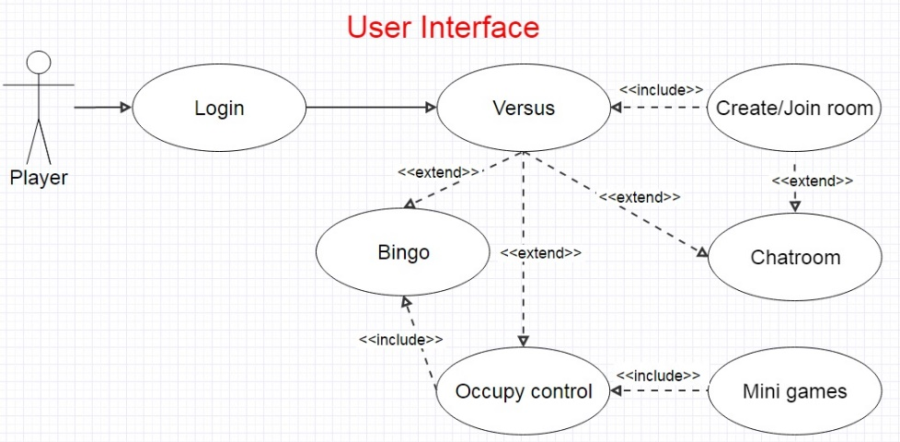Users have to create account and open a room for 2 teams of players to race against each other. After randomly create the bridge map for the generators, players have to head to those places and occupy them by playing *Satellite Hack*, an augmented reality mini game that players move their smartphone until its camera points at the GPS satellite within time limit.

figure 1

The generators will increase scores for the team that occupy them. When the time is up or one of the teams forms a bridge (a straight line on BINGO map of generators), extra points for the bridge winner are rewarded and the game is ended. The team with higher score will win this game.

1. **Description of the Design and Major Features**
   * 1. **User Interface**

The main activity of application is used for login and registration. When the application starts, it will provide two fields for user to type user name and password. There is a login button to perform login and register button to open a new activity for user to register new account.

There is a home page after login. The home page will show the corresponding online, settings and about page. If a user opening the application in Mong Kok, when he presses the online button, it will direct the user to the Mong Kok Lobby of the game. (Figure 1)

Inside the Lobby interface, it has a room list that a user can join, which is showing by a table layout. At the bottom of Lobby interface will also showing a button for user to open a new game room.

In game room activity, it will wait for enough players to start the game. It will showing by grid layout which is two columns. The two teams name will at the first row and the team member list is following on the rows.

Once the game start, the UI will change to a map which showing the GPS of user and the generator of that region. There is also a textview to showing the score and dominion status which will continuously update. When user gets close to generator, he or she can click a button and play the mini game to dominate that generator.(Figure 2)

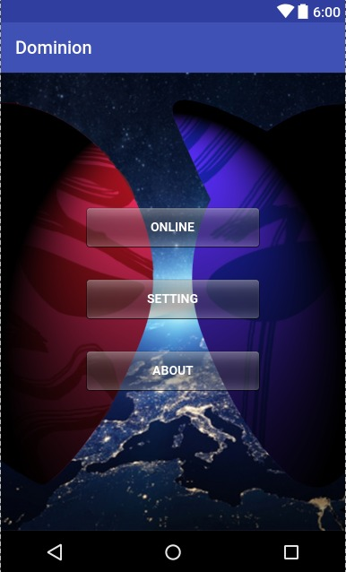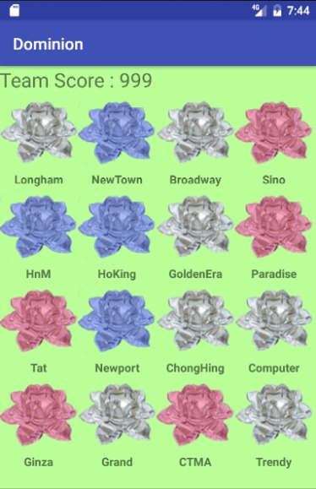

figure 2 figure 3

In the mini game, Satellite Hack, camera will be turned on with a sight (circle with a cross) at the center of the screen and user will see the screen turning red as well. Within a certain time, before the sight rotation stops, user has to turn their smart phone to point at a designated GPS satellite. When user is getting close to the target, the sight will become smaller. When it is getting close enough, a “Hack” button will show up so that user can click it to dominate the generator.

* + 1. **Information flow**

There is four section of information flow, includes registration and login, enter game room to start the game, dominion in the game and finally ending the game.

Registration is simple, user send user data to database through register function. Login is similar by sending username and password, and it is verify by login function. The home function will send user id to GPS and it returns the region of user.

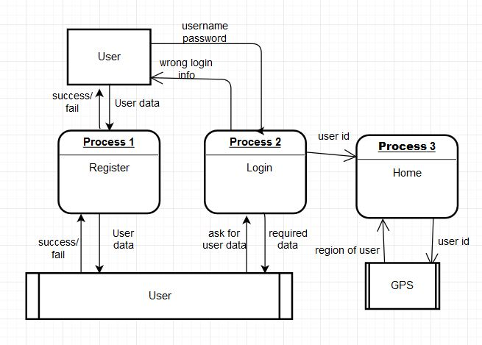 figure 4

In entering the game room, the lobby will send a room list of that region to user. The user will send room id and user id if user wants to enter a specific room. If user wants to open a game room, he will send his own user id to open room function. Finally when the game ready to start, it will update status and start time to Room table.

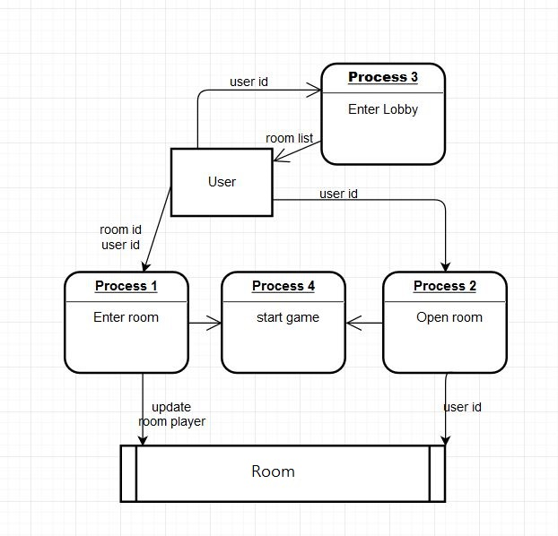 figure 5

Inside the game, user will continue sending GPS and the check nearby Generator function will receive that GPS and check from the Generator table. If user is nearby a Generator, user can dominate it, if it is success, it will update a record in game dominion. Moreover, the server will continuously updating the score of each game.

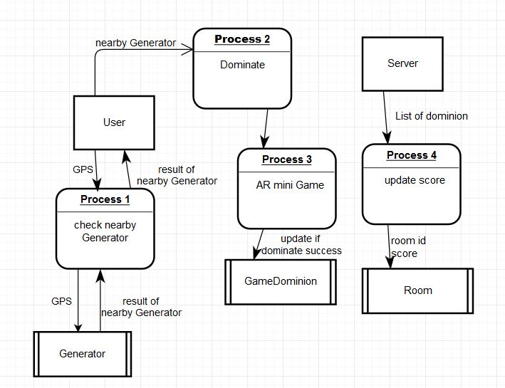 figure 6

Each dominate will also check is there any bridge (bingo) of the game, it will send user id to Game dominion table, and it will return a list of dominated generator by the team of user. When there is a team to bridge or time is up, server will send the room id to end game function for ending the game.

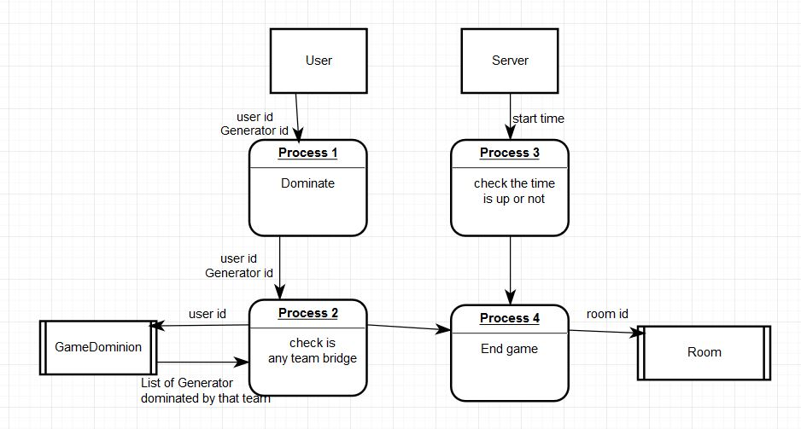 figure 7

* + 1. **Modules**

There are web servers, users, game, Google map Android API, hardware and database modules.

Web server is used for processing the game Information between user and game like updating the score of game and send to user, also it will updating the database.

User can perform action through the web server. For example, user can open a new game room by sending its user id to server, and server will insert a new room in database and then return to user. User can also control the hardware device to use camera play AR mini game, walking in the real world to change the GPS of the phone.

The game is used for keep updating the location of a user by the GPS signal. And it will let user to start the Satellite Hack (mini game) when user arrive a specific location.

Google map Android API will provide a map for user to playing the game because user needs to walk to a place that has Generator.

Hardware is used for giving GPS to the game and using its camera to play the game.

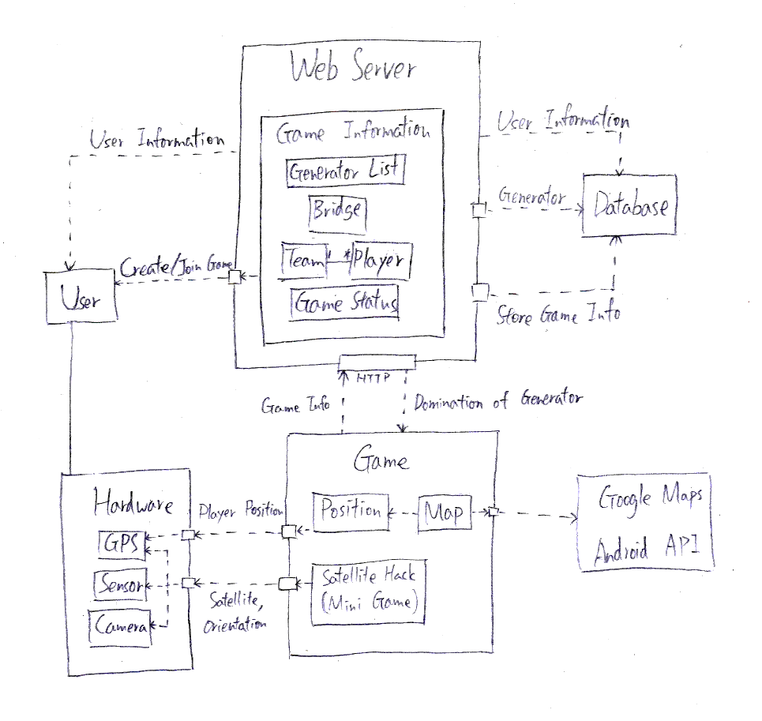Database is used to store all the user and game information.

figure 8

1. **The prototype implementation**
   * 1. **The language development technology**

We have to handle a variety of situation as this project is a battle game. Methods and functions are written to cope with different needs like score counting, judgment and other logical parts, in Java. Besides, we are using MySQL database for storing the datasets such as user information, game information and the point’s coordinates. PHP is used as the server side language to perform server action. In order to increase the fun of gameplay, we are going to develop AR mini-game inserted within mainline.

The location based part would be one of the essential components, which is supported by the SDK – “Google Play Service”. It helps a lot in getting the coordinates divided into latitude and longitude from players. Google Map API will be applied into the user interface for coordinate performance.

With a view to drawing more users, we are considering to have integration with IM and social networking site like “Whatsapp” and “Facebook”. Maybe there a dialog box requesting the player to share their victory with the above applications

* + 1. **The dataset**

First, there is a table that storing simple user information including user id, user name, password and the time of win of user.

Then, there is a Lobby table to store lobby information include the Lobby id and the corresponding region of that Lobby. Inside a lobby, there are some game rooms. So that there is a Room table to store room information includes room id, the create time of the game, which Lobby it is in, the status of game like waiting, running or finished. Also it will store the score of the two teams in that room. Furthermore, another table RoomPlayer will store the player in that room.

Inside the game, the player will keep trying to dominate the different Generator, so there is a GameDominion table to store that information. It has room id, the user id who dominated it, the Generator id, the time of dominate and the number of dominion of that generator in that game. Besides, there is a RegionGenerator table to store basic information of Generator like GeneratorID, the region of it, the map location of that Generator and finally the name of Generator.

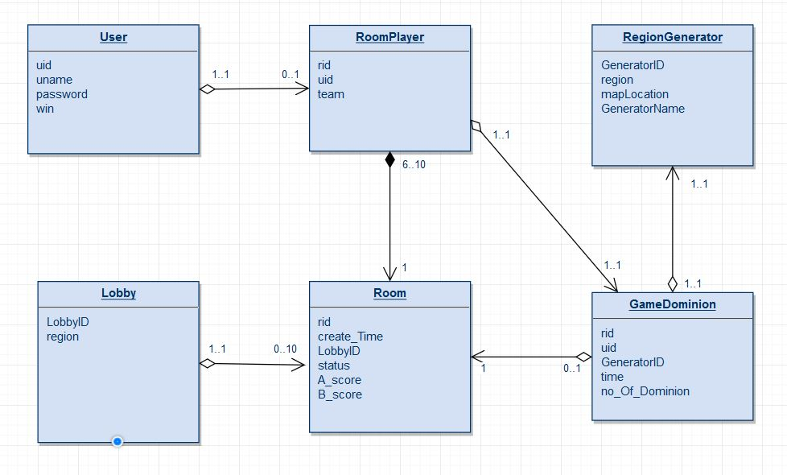

figure 9

1. **Evaluation Plan**

The project will be evaluated in both qualitative and quantitative ways.

We will invite 12 youth aging from 18 to 25, mainly pre-graduate, android-user to form 4 teams of player to play the game for 1 to 2 rounds in Mong Kok. After each rounds they are interviewed about the user experience of the game. We will also ask for feedbacks for enhancing the game. The draft questions are as below.

User Interface:

* Have you found difficulty using the user interface? Can you find and use the functions you want?
* Is the application efficient? Have you found any repeated or unnecessary process?

Game:

* Do you enjoy playing *Dominion of City*?
* Does the game provide clear information of the tasks?
* What is the difficulty in the last round?
* How do you evaluate your performance?
* How do you think we can enhance the game?

Social Activity:

* Do you think communication is important to win this game?
* Can this game encourage you to interact with teammates, when they are your friends or strangers?

Exploring

* What places have you been due to this game?
* Can this game encourage you to explore Mong Kok?
* Do you think you pay more attention to the surrounding during the game?

Quantitatively, we will test the accuracy and speed of some major use-cases:

* Register/Login
* Display game list in game lobby
* Create/Join Game
* Get game information
* Dominate generator

# **Reference**

Barker, S. (25 Aug 2016). *Student play’Pokemon Go’ for physical, social benefits* Retrieved from <http://search.proquest.com.ezproxy.lib.ouhk.edu.hk/docview/1814002575?rfr_id=info%3Axri%2Fsid%3Aprimo>

Cranford, R. (25-31 Jul 2016). *‘Pokemon Go’ and Social Marketing* Retrieved from <http://search.proquest.com.ezproxy.lib.ouhk.edu.hk/docview/1810255881?OpenUrlRefId=info:xri/sid:primo&accountid=16720>

The Office of the Ombudsman, Hong Kong (2012) *主動調查報告 康樂及文化事務署 體育設施的預訂和使用*, Hong Kong: The Office of the Ombudsman.

Teng, C. I., Huang, H. C., & Chen, J. L. (2015). Social Networking and Continuance Intention among Online Gamers. *臺大管理論叢*, *25*(2), 1-22.

Hsiao, C. C., & Chiou, J. S. (2012). The effects of a player’s network centrality on resource accessibility, game enjoyment, and continuance intention: A study on online gaming communities. *Electronic Commerce Research and Applications*, *11*(1), 75-84.

Snodgrass, J. G., Lacy, M. G., Dengah, H. F., & Fagan, J. (2011). Enhancing one life rather than living two: Playing MMOs with offline friends. *Computers in Human Behavior*, *27*(3), 1211-1222.

Wang, H., & Sun, C. T. (2011, September). Game reward systems: gaming experiences and social meanings. In *Proceedings of DiGRA 2011 Conference: Think Design Play*, 1-12.

# **Appendix A—Progress Report**

Overview of Project progress

The progress is a bit delayed due to examination but still satisfactory. The major parts of the game including management of generator, score counting, game judgment, information exchange are 90% done. *Satellite Hack* (mini game) is delayed but should be able to catch up the schedule. It is more than 60% done.

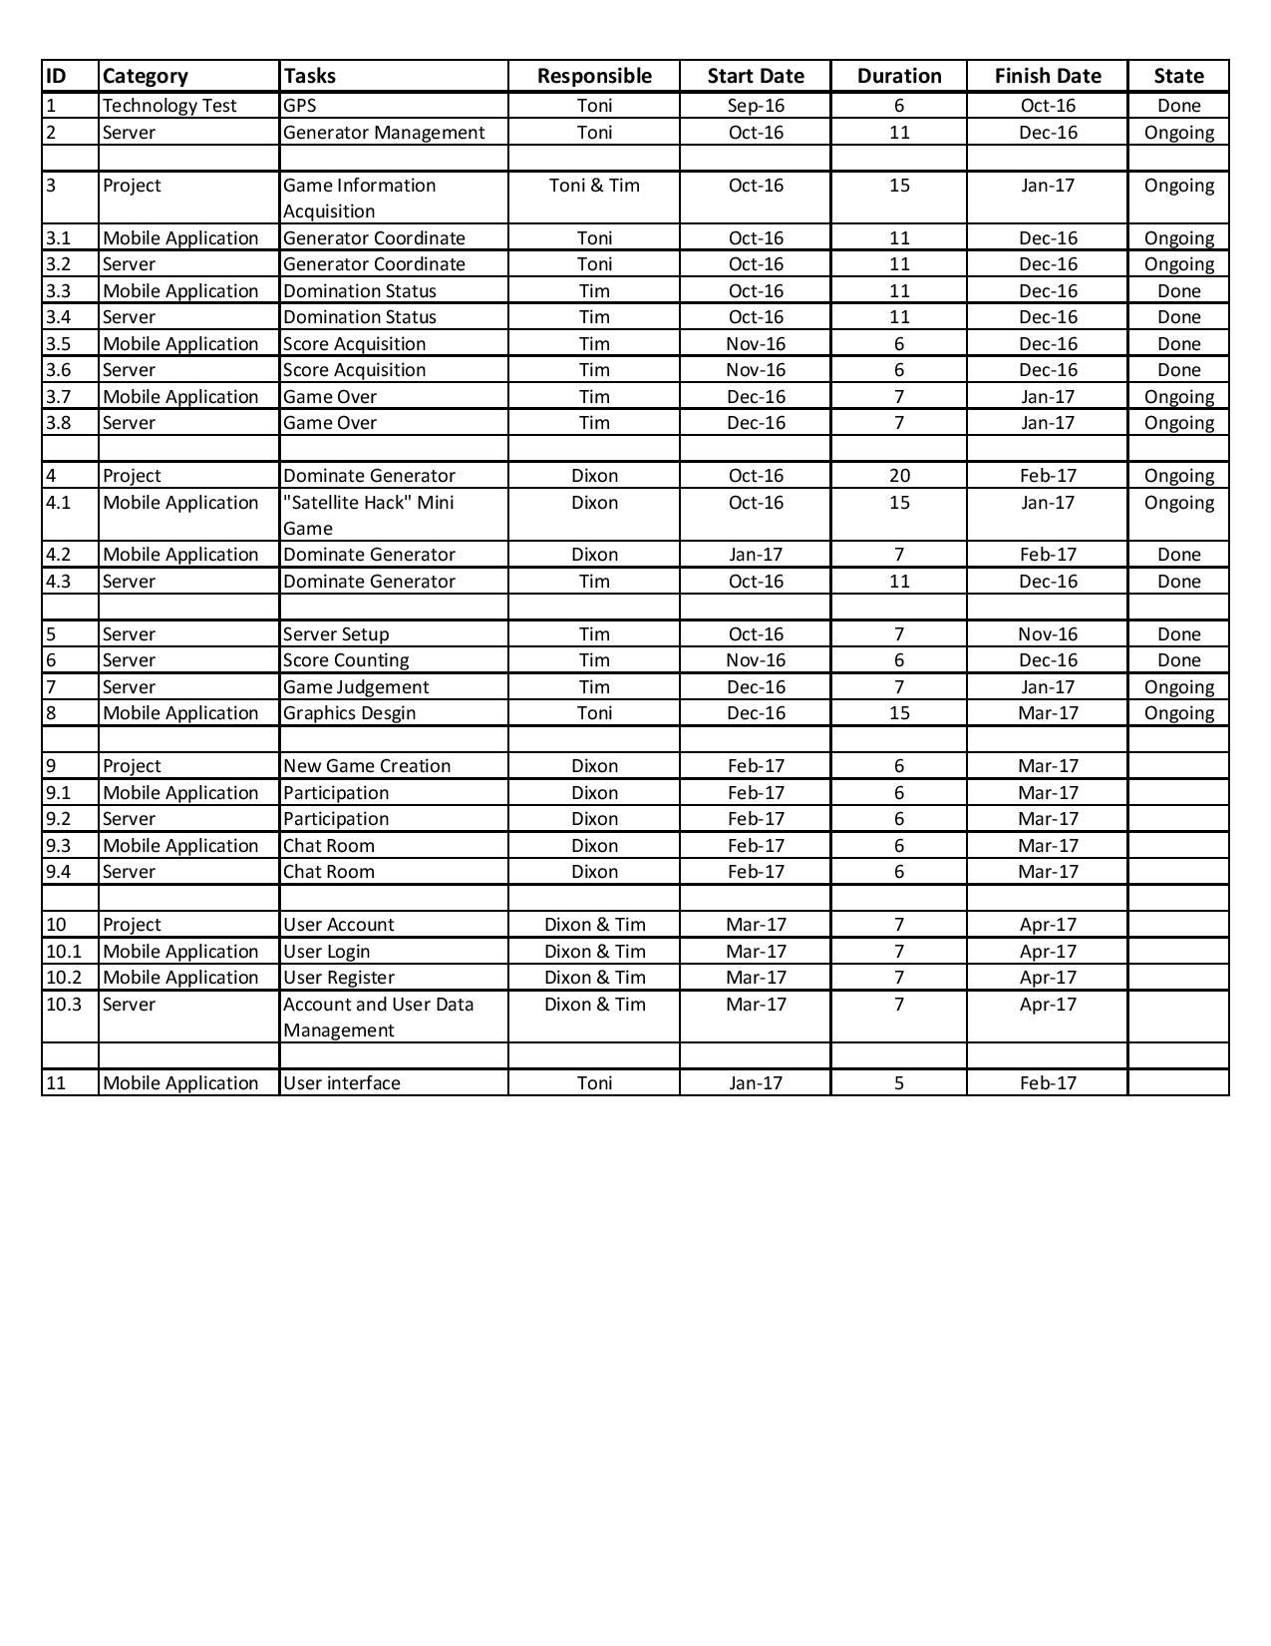Some other tasks have started earlier for the ease of development like account management, user interface.

figure 10

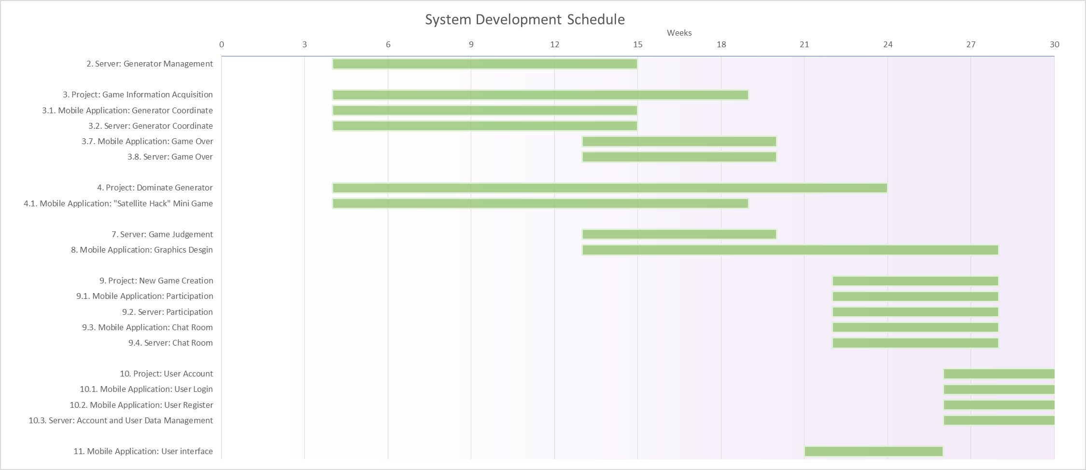

figure 11

# **Appendix B--Members’ Roles and Responsibilities**

* + Team Coordinator, Secretary: Dixon Wong
  + Database Expert: Tim Leung
  + AR Expert: Dixon Wong
  + GPS Expert: Toni Tang
  + System Analysis & Design: Dixon Wong, Tim Leung, Toni Tang
  + Programmer: Dixon Wong, Tim Leung, Toni Tang
  + Tester & Evaluator: Dixon Wong, Tim Leung, Toni Tang

# **Appendix C--Meeting Minute**

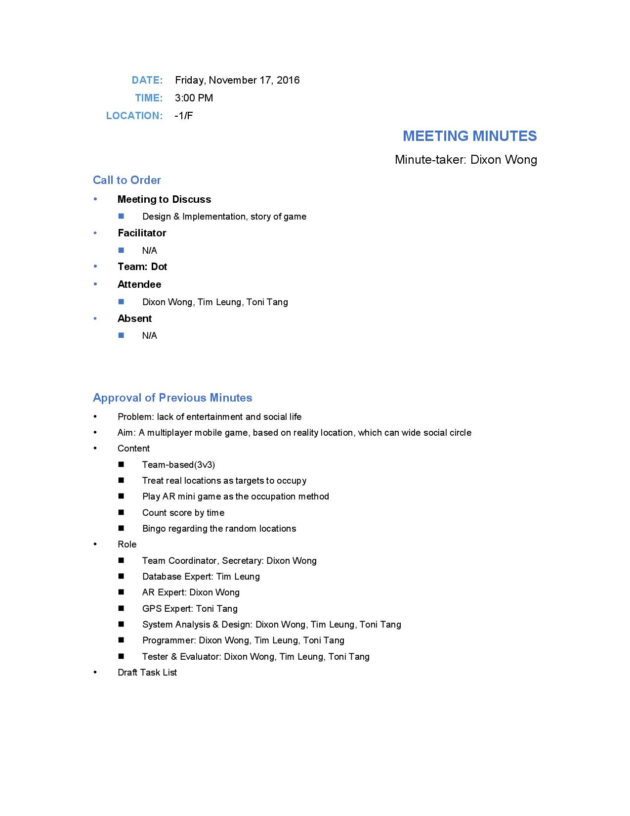

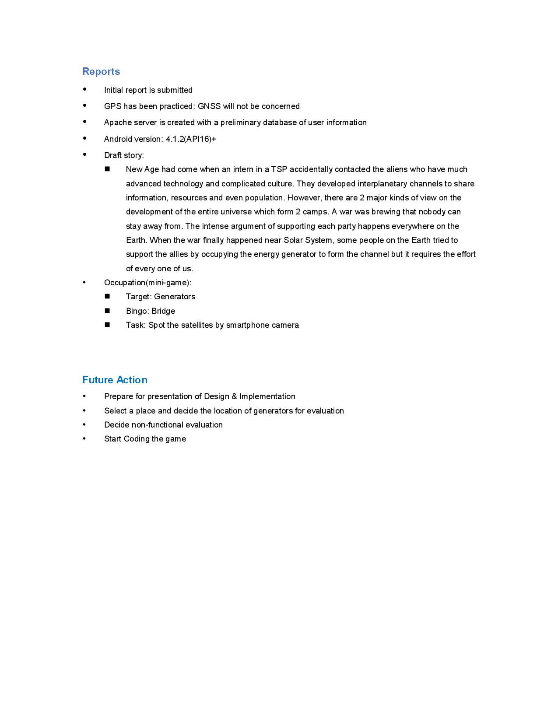

**Appendix D1: Team Member’s Interim Report**

**Information**

Student Name: Leung Man Him

OUID: 11182527

Project Team Name: dot

Project Title: Dominion of City: Real Time Strategy Location-based Mobile Game

Supervisor: Li Tak Sing

**Declaration:**

I, Leung Man Him(OUID: 11182527), certify that the work is original and I have utilized guidance of our supervisor in completing this project, and that the content which is not our own has been attributed and referenced properly. There should be no copyrighted content without permission to use. There should be no confidential data.

Signature: _______________

Date: _______________

**Task Assigned to the Author and their status**

I am mainly responsible for the information acquisition between the android application and database. I have already built a database to store the information within the game, which is mentioned in the previous part. Also, some tasks like inserting data to database after dominion and response to the application are finished. Later I will work on the action between database and application after the game is ended. Moreover, I will building a user account system with Dixon later.

The following table outlines the task assigned t me in this project.

|  |  |  |  |  |
| --- | --- | --- | --- | --- |
| Tasks | Responsible Members | Target Date | Completion | Remarks |
| Game Information Acquisition | Toni and Tim | Jan 2017 | 70% |  |
| Server: Domination Status | Tim | Dec 2016 | 100% |  |
| Application: Domination Status | Tim | Dec 2016 | 100% |  |
| Server: Score Acquisition | Tim | Dec 2016 | 100% |  |
| Application: Score Acquisition | Tim | Dec 2016 | 100% |  |
| Server: Game Over | Tim | Jan 2017 | 80% |  |
| Application: Game Over | Tim | Jan 2016 | 50% |  |
| Dominate Generator | Tim | Dec 2016 | 100% |  |
| Server Setup | Tim | Nov 2016 | 100% |  |
| Server: Score Counting | Tim | Dec 2016 | 100% |  |
| Game Judgement | Tim | Jan 2017 | 80% |  |
| User Account | Dixon and Tim | Apr 2017 | 0% |  |
| Server: Account and User Data Management | Dixon and Tim | Apr 2017 | 0% |  |

**Key Success and failure:**

The application that I have done is already can insert data to database and show a response that it is successfully added. Also it can successfully acquire the data from database and showing it in the textview of the application.

However, it is not showing in my preferred format now. For example, taking the dominion status of a game, I generated a list that showing a dominated Generator list, but I want it to combine with the non-dominated Generator to show a full list to user. I am still working on it.

**Appendix D2: Team Member’s Interim Report**

**Information**

Name: Wong Tik San (OUID: 11181021)

Team: dot

Project: Dominion of City: Real Time Strategy Location-based Mobile Game

Supervisor: Li Tak Sing

**Declaration**

I, Wong Tik San (OUID: 11181021), certify that the work is original and I have utilized guidance of our supervisor in completing this project, and that the content which is not our own has been attributed and referenced properly. There should be no copyrighted content without permission to use. There should be no confidential data.

______________________________________

Signature and Date

**Task**

I am responsible for development of *Satellite Hack*, the augmented reality mini game in the project. Later on I will work on game creation and participation, and chat room at the same time. Lastly, Tim and I will cooperate to manage user accounts, including login and register functions.

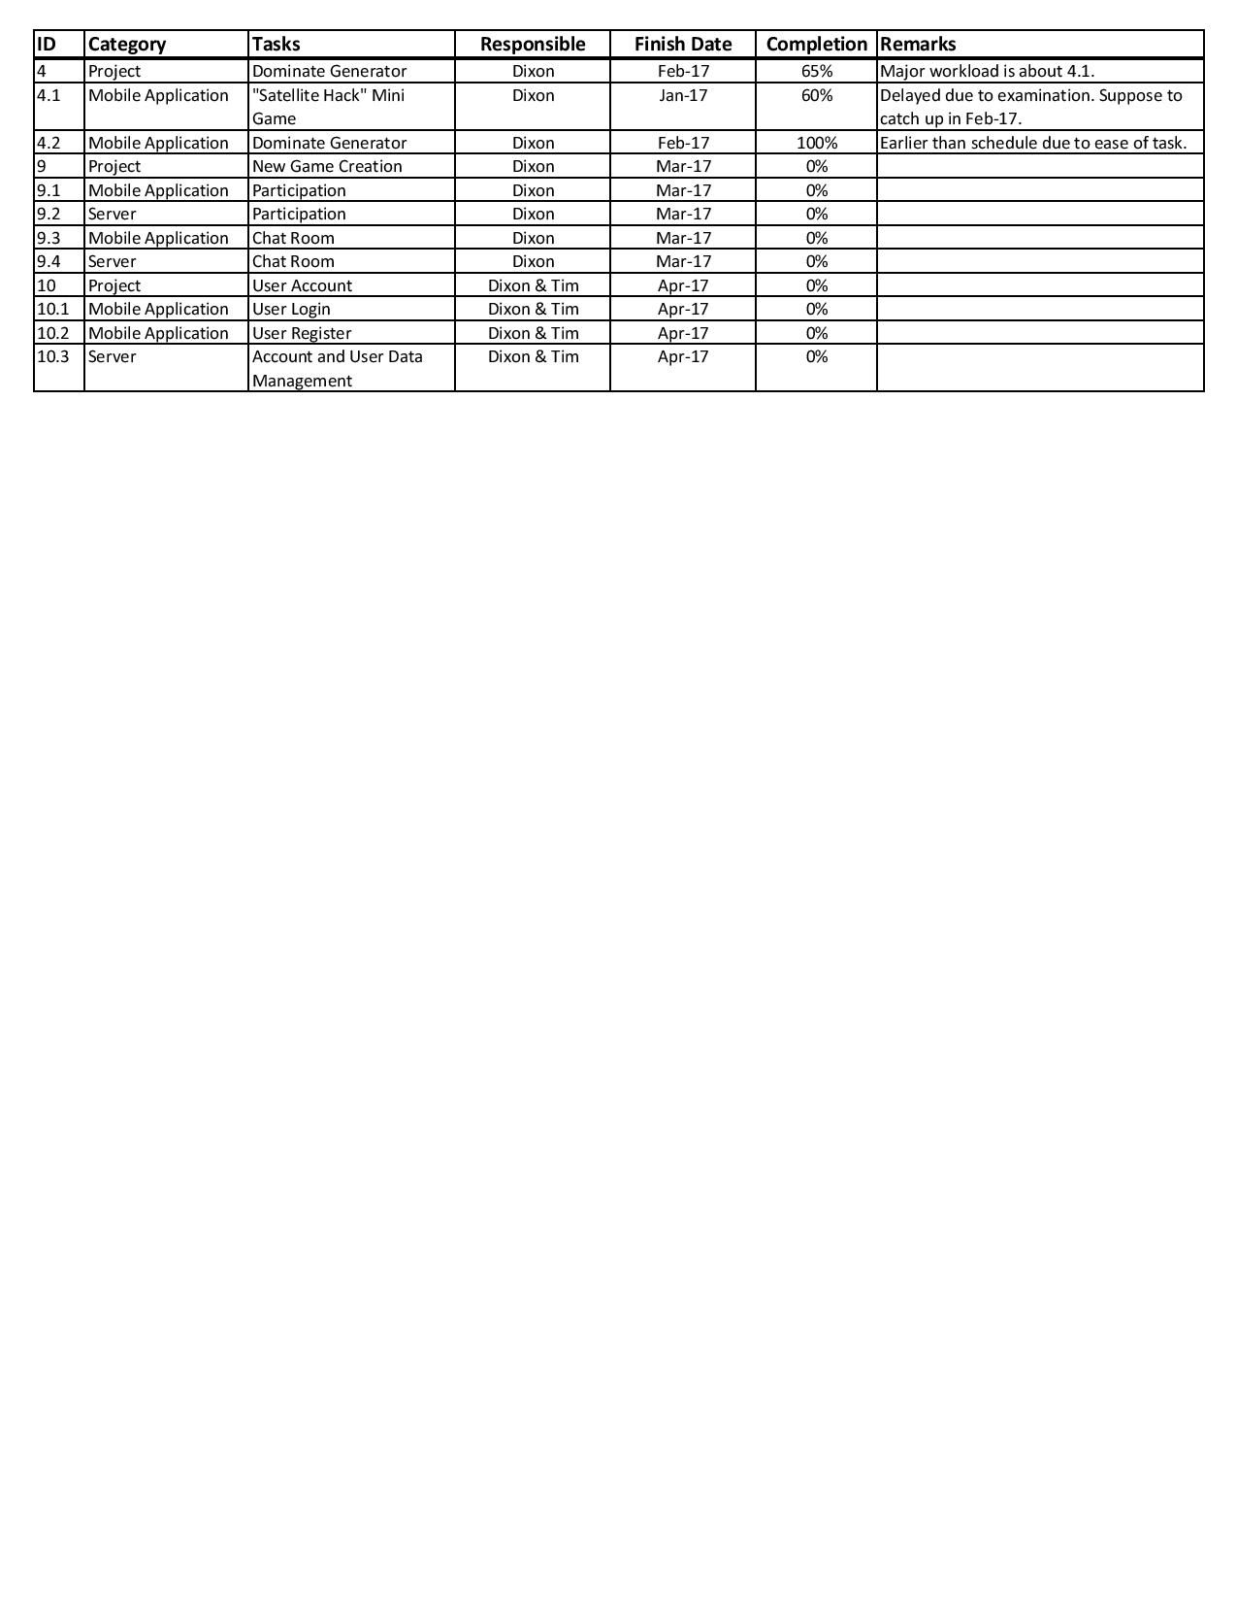*Satellite Hack* development is slower than expected (60% done) but not unsatisfactory. It is still supposed to be on time. Game creation development will begin as scheduled in later February.

**Key Success and Failure**

We was developing a mini game that highly relied on augmented reality. We then discussed the game background and developed another idea of the mini game related to that. However, the mini game is not applying high-level vision-based augmented reality technology. It is my key failure that decrease the interaction between reality and the game. Besides, the time studying AR development tools is wasted.

In contrast, the project plan is clearer as the narrative is decided. The mini game is also considered less important than exploring the city. The lower technical requirement also shorten the development time.

**Appendix D3: Team Member’s Interim Report**

**Information**

Student Name: Tang Chi Ho

OUID: 11145882

Project Team Name: dot

Project Title: Dominion of City: Real Time Strategy Location-based Mobile Game

Supervisor: Li Tak Sing

**Declaration:**

I, Tang Chi Ho (OUID: 11145882), certify that the work is original and I have utilized guidance of our supervisor in completing this project, and that the content which is not our own has been attributed and referenced properly. There should be no copyrighted content without permission to use. There should be no confidential data.

Signature: _______________

Date: _______________

**Task**

I am mainly responsible for location based section in the project, including getting the coordinates from the device and the target coordinate pairing. I am now coping with the connection between the application and the database.

After completed the major part of the GPS, I will work on the user interface and graphics design that I hope the user will feel comfortable to every pieces of this application.

|  |  |  |  |
| --- | --- | --- | --- |
| **Tasks** | **Responsible** | **Target Date** | **Completion** |
| GPS Test | Toni | Oct-16 | 100% |
| Server: Generator Management | Toni | Dec-16 | 80% |
| Game Information Acquisition | Toni & Tim | Jan-17 | 70% |
| Application: Coordinate Acquisition | Toni | Dec-16 | 70% |
| Server: Generator Coordinate | Toni | Dec-16 | 100% |
| Graphics Design | Toni | Mar-17 | 30% |
| User interface | Toni | Feb-17 | 50% |

**Key Success and Failure**

The current obstacle for my work is that I lack of the technical knowledge for the server action, I am going concern the coordinates handling in the server side.

In developing the GPS part, there is fortunately many sources and tutorial video about making GPS. It give a big hand to me and I successfully completed the part of getting coordinates from device after installed the related tools and packages.

Graphics and UI are fined for me and they look smooth so far.